

Computer Vision

Section-1

Submitted to faculty: Professor Mehul Raval

Date of Submission: 06-04-2022

Student Details

Computer Vision-Super Image Resolution

| Roll No. | Name of the Student | Name of the Program |
| --- | --- | --- |
| AU1940109 | Jap Purohit | CV |
| AU1940034 | Varun Deliwala | CV |
| AU1940267 | Sahil Miskeen | CV |
| AU1940142 | Shail Patel | CV |

**Tasks performed this week:**

We started to work with transpose convolutions which can be used for increasing the resolution of the images automatically as opposed to the manual bicubic interpolation which we were doing before. The input image is scaled by a factor of 2 from the model itself. The model is attached below.

**Outcomes:**

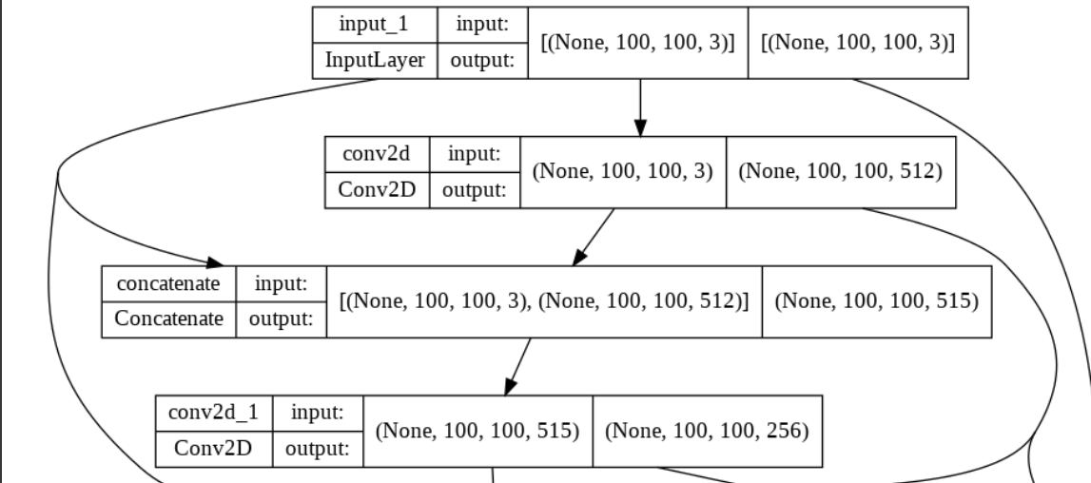

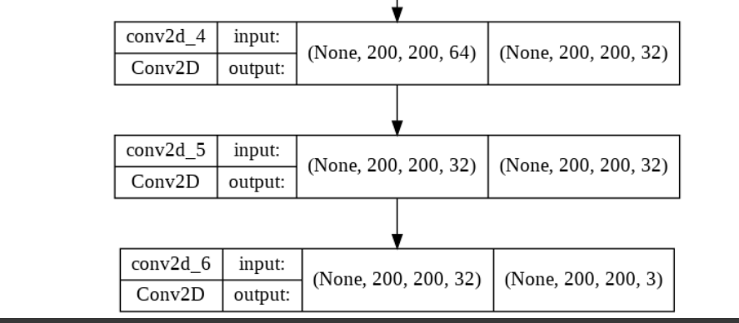

As visible the input 100*100*3 is scaled by a factor of 2.

The output of the image is shown below

**Low Resolution Image (100 * 100 * 3)**

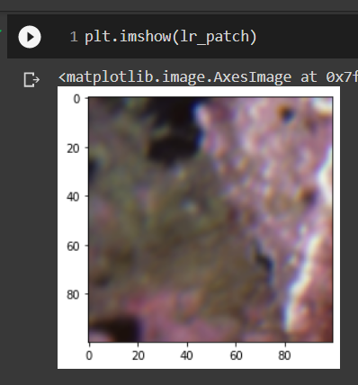

**High Resolution Image Model Predicted (200 * 200 * 3)**

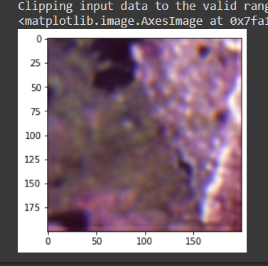

**The model is able to scale the low resolution image by a factor of 2 which has been specified by us while training the model.**

**Tasks to be performed next week:**

Implement GAN models and see if we can make the process dynamic as in get the input from the user to which factor does he want to scale the image to.